5/11/2015

Steven Whyte

[company name]

Leaf & Lawn

Relational Database design proposal

**Executive Summary**

This database describes a landscaping company (Leaf and Lawn). This landscaping company does not only focus on cutting grass and trees, it focuses on its customers, employees and equipment.  The company has multiple employees, trucks and equipment that they must keep track of. They service many customers in different towns.

This database will keep track of their employees, customers, trucks and equipment, payments and appointments.

Upon completion this database will be able to:

·      Keep track of who their customers are.

·      What service their customers require.

·      When the service is required.

·      Who completed the service.

·      Time spend on service.

·      Cost of service.

·      Equipment and tools own by the company.

·      Service date/ Record of equipment/ Trucks.

·      An employee will be able to take multiple orders daily and an order can have multiple

employees.

·      A customer may have multiple homes but each home may have one customer.

·      An employee may use multiple equipment.

·      And vehicle may be driven by many employees’ daily.

Top of Form

Create Statements

CREATE TABLE Appointment

(

AppointmentId INTEGER NOT NULL ,

"Date" DATE ,

TIME DATE ,

Customers_CustomerId INTEGER NOT NULL ,

Service_ServiceId INTEGER NOT NULL ,

Employees_EmployeeId INTEGER NOT NULL ,

Vehicle_VIN VARCHAR2 (20) NOT NULL ,

Equipment_SerialNo INTEGER NOT NULL ,

Property_PropertyId INTEGER NOT NULL ,

Property_CustomerId INTEGER NOT NULL

) ;

ALTER TABLE Appointment ADD CONSTRAINT Appointment_PK PRIMARY KEY ( AppointmentId ) ;

CREATE TABLE Customers

(

CustomerId INTEGER NOT NULL ,

FName VARCHAR2 (20) NOT NULL ,

LName VARCHAR2 (20) NOT NULL ,

SpouseFName VARCHAR2 (20) ,

SpouseLName VARCHAR2 (20) ,

Street VARCHAR2 (20) NOT NULL ,

City VARCHAR2 (30) NOT NULL ,

State VARCHAR2 (30) NOT NULL ,

Zip CHAR

-- WARNING: CHAR size not specified

NOT NULL ,

Phone_home VARCHAR2 (20) ,

Phone_work VARCHAR2 (20)

) ;

COMMENT ON COLUMN Customers.SpouseFName

IS

'Optional' ;

COMMENT ON COLUMN Customers.SpouseLName

IS

'Optional' ;

COMMENT ON COLUMN Customers.Phone_work

IS

'Extention: optional' ;

ALTER TABLE Customers ADD CONSTRAINT Customers_PK PRIMARY KEY ( CustomerId ) ;

CREATE TABLE Employees

(

EmployeeId INTEGER NOT NULL ,

SSN CHAR (9) ,

FName VARCHAR2 (20) NOT NULL ,

LName VARCHAR2 (20) NOT NULL ,

Street VARCHAR2 (20) NOT NULL ,

City VARCHAR2 (30) NOT NULL ,

State VARCHAR2 (30) NOT NULL ,

Zip CHAR

-- WARNING: CHAR size not specified

NOT NULL ,

Phone_home VARCHAR2 (20) ,

Phone_work VARCHAR2 (20)

) ;

COMMENT ON COLUMN Employees.Phone_work

IS

'Extention: optional' ;

ALTER TABLE Employees ADD CONSTRAINT Employees_PK PRIMARY KEY ( EmployeeId ) ;

CREATE TABLE Equipment

(

SerialNo INTEGER NOT NULL ,

Name VARCHAR2 (20) ,

Make VARCHAR2 (30) ,

Model VARCHAR2 (30) ,

PurchaseDate DATE ,

ServiceDate DATE ,

Use VARCHAR2 (30)

) ;

ALTER TABLE Equipment ADD CONSTRAINT Equipment_PK PRIMARY KEY ( SerialNo ) ;

CREATE TABLE Property

(

PropertyId INTEGER NOT NULL ,

CustomerId INTEGER NOT NULL ,

Street VARCHAR2 (30) CONSTRAINT NNC_Property_Street NOT NULL ,

City VARCHAR2 (30) CONSTRAINT NNC_Property_City NOT NULL ,

State VARCHAR2 (30) CONSTRAINT NNC_Property_State NOT NULL ,

Zip CHAR

-- WARNING: CHAR size not specified

CONSTRAINT NNC_Property_Zip NOT NULL ,

SquareFt NUMBER

) ;

COMMENT ON COLUMN Property.SquareFt

IS

'Size' ;

ALTER TABLE Property ADD CONSTRAINT Property_PK PRIMARY KEY ( PropertyId, CustomerId ) ;

CREATE TABLE Service

(

ServiceId INTEGER NOT NULL ,

ServiceType VARCHAR2 (50) ,

PricePerSqFt NUMBER

) ;

ALTER TABLE Service ADD CONSTRAINT Service_PK PRIMARY KEY ( ServiceId ) ;

CREATE TABLE Vehicle

(

VIN VARCHAR2 (20) NOT NULL ,

Make VARCHAR2 (20) ,

Model VARCHAR2 (20) ,

Color VARCHAR2 (20) ,

YEAR CHAR (4) ,

Plate# VARCHAR2 (10) ,

PurchaseDate DATE ,

LastServiceDate DATE

) ;

ALTER TABLE Vehicle ADD CONSTRAINT Vehicle_PK PRIMARY KEY ( VIN ) ;

ALTER TABLE Appointment ADD CONSTRAINT Appointment_Customers_FK FOREIGN KEY ( Customers_CustomerId ) REFERENCES Customers ( CustomerId ) ;

ALTER TABLE Appointment ADD CONSTRAINT Appointment_Employees_FK FOREIGN KEY ( Employees_EmployeeId ) REFERENCES Employees ( EmployeeId ) ;

ALTER TABLE Appointment ADD CONSTRAINT Appointment_Equipment_FK FOREIGN KEY ( Equipment_SerialNo ) REFERENCES Equipment ( SerialNo ) ;

ALTER TABLE Appointment ADD CONSTRAINT Appointment_Property_FK FOREIGN KEY ( Property_PropertyId, Property_CustomerId ) REFERENCES Property ( PropertyId, CustomerId ) ;

ALTER TABLE Appointment ADD CONSTRAINT Appointment_Service_FK FOREIGN KEY ( Service_ServiceId ) REFERENCES Service ( ServiceId ) ;

ALTER TABLE Appointment ADD CONSTRAINT Appointment_Vehicle_FK FOREIGN KEY ( Vehicle_VIN ) REFERENCES Vehicle ( VIN ) ;

ALTER TABLE Property ADD CONSTRAINT Property_Customers_FK FOREIGN KEY ( CustomerId ) REFERENCES Customers ( CustomerId ) ;

Bottom of Form

Tables

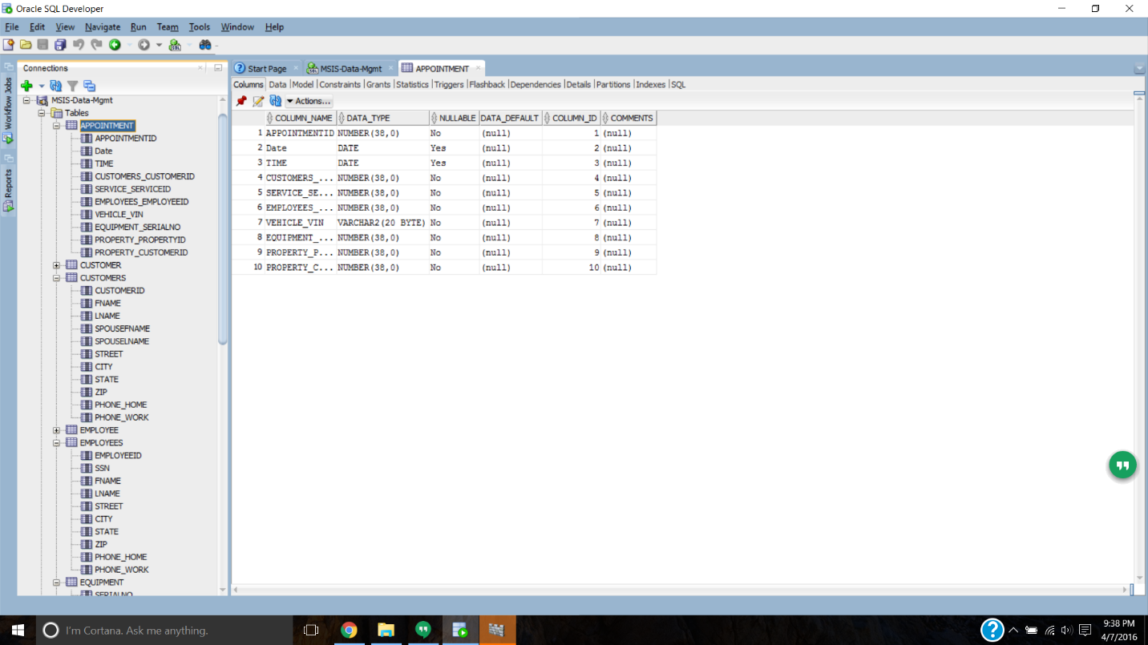

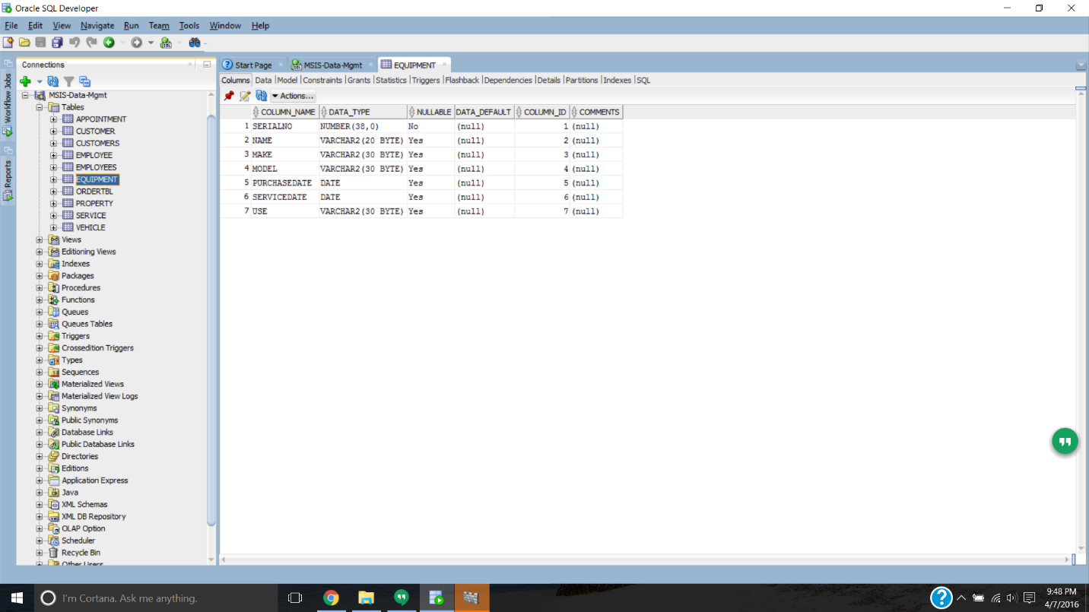

ERD

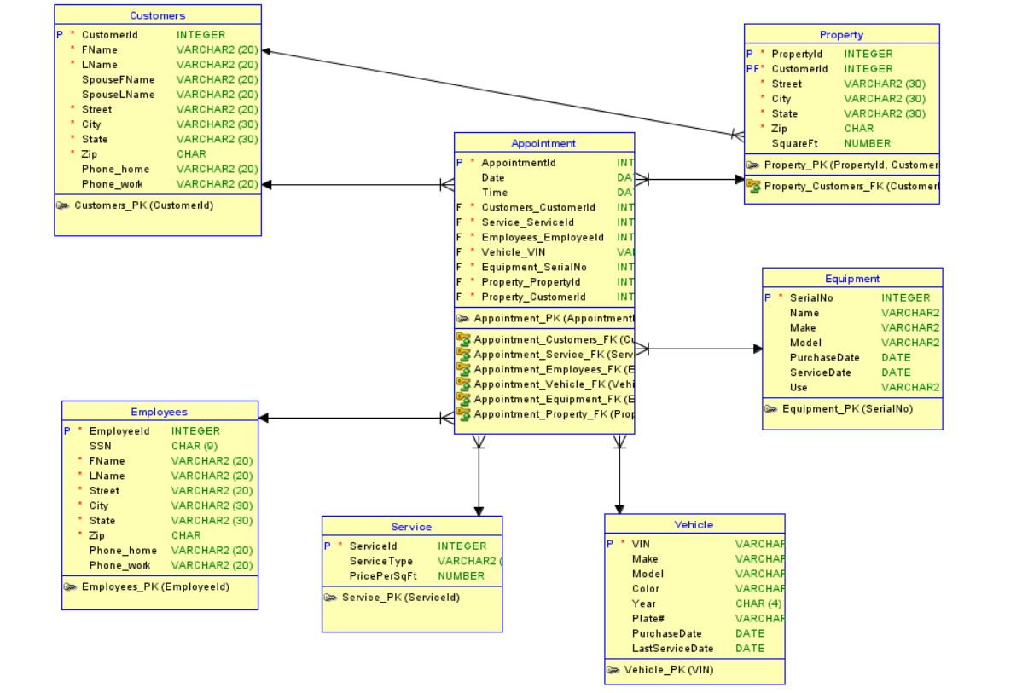

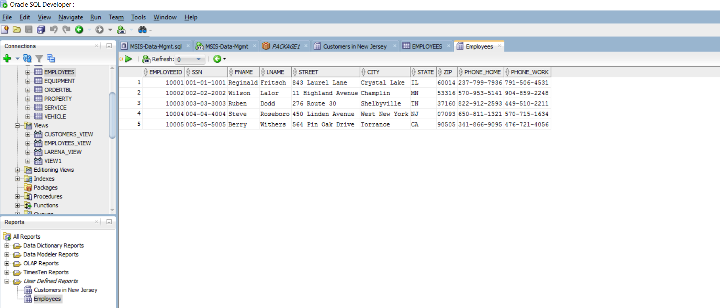Reports

Employees

reports

Customers in NJ

